Amar strong recommendation
Tomar project er jonno best professional stack:
Frontend
- Next.js
- Tailwind CSS
- clean dashboard UI
Backend
- FastAPI (Python)
- because tumi basic coding jano, Python side e AI + file parsing + ATS logic easier hobe
Database
- PostgreSQL
Auth + File Storage
- Supabase
- user login
- CV upload
- cover letter upload
- JD upload
- file storage + DB support
AI
- OpenAI API
- JD parsing
- ATS match score
- CV rewrite
- cover letter rewrite
- reminders content
- interview prep suggestions
Notifications
- Twilio
- SMS reminder to phone
Hosting
Two good options:
Option A — easier and cleaner
- Frontend on Vercel
- Backend on Render or Railway
- Database/Auth/Storage on Supabase
Option B — simpler full backend hosting
- Frontend + backend on Railway/Render
- Supabase for auth/storage/db
For your case, Option A is best.
Reason: Vercel is great for frontend deployment, Supabase handles auth/storage/db, and FastAPI backend can run separately on Render or Railway. Supabase provides Postgres/Auth/Storage/Realtime; Railway documents a SaaS backend pattern with API + DB + worker + cron; Render documents web services and persistent disk behavior.

Final architecture
1) Web app
User browser e website open korbe
2) Frontend dashboard
Sections:
- Dashboard
- Add Job
- Tracker
- ATS Checker
- CV Builder
- Cover Letter Builder
- Interview Reminders
- Settings
3) Backend API
FastAPI service handle korbe:
- job create/update
- status changes
- file upload processing
- AI analysis requests
- reminder scheduling
- SMS trigger
- follow-up suggestions
4) Database
PostgreSQL tables:
- users
- jobs
- applications
- job_status_history
- uploaded_documents
- ats_analysis
- reminders
- generated_documents
5) Storage
CV, cover letter, JD, generated files → Supabase Storage
6) AI orchestration
OpenAI API:
- extract job details from pasted post
- ask “add to tracker?”
- compare CV with JD
- generate ATS suggestions
- rewrite CV bullets
- create tailored cover letter
- suggest follow-up email
- generate interview prep notes
7) Notification system
Background worker + cron:
- upcoming interview check
- follow-up reminder check
- SMS send through Twilio
Railway’s guide explicitly shows using a separate worker/cron architecture for scheduled tasks, and Twilio’s messaging quickstart covers programmatic SMS sending.

Professional product features
Core tracker statuses
- Need to Apply
- Applied
- Got Response
- Interview Call
- Need Review
- Rejected
- Offer
Smart job intake
User paste korbe:
- job link
- job description
- company name optional
AI:
- company detect korbe
- title detect korbe
- location detect korbe
- skills detect korbe
- deadline detect korbe jodi thake
- ask korbe: “Do you want to add this to tracker?”
ATS engine
User upload korbe:
- resume
- cover letter
- job description
System:
- JD parse korbe
- skills extract korbe
- missing keywords ber korbe
- match score dibe
- bullet suggestions dibe
- summary rewrite dibe
- cover letter tailored version dibe
Interview reminder system
User interview time dile:
- DB te save hobe
- 24h আগে reminder
- 2h আগে reminder
- optional morning reminder
- SMS + in-app notification
Need review agent
AI identify korbe:
- applied but no follow-up after 5–7 days
- interview scheduled but no prep notes
- JD added but no tailored CV
- missing cover letter in jobs where one may help

Best development approach
Tomar jonno ami 3 phase plan recommend korchi.
Phase 1 — Foundation
Build:
- auth
- DB
- job tracker CRUD
- file upload
- dashboard
Phase 2 — AI features
Build:
- JD parser
- ATS checker
- CV rewrite
- cover letter generator
- job recommendations
Phase 3 — automation
Build:
- SMS reminders
- scheduled follow-ups
- agentic review queue
- interview prep generator

Which stack should you choose exactly?
My exact recommendation
Use this:
- Next.js → frontend
- FastAPI → backend
- Supabase → auth + postgres + storage
- Twilio → SMS
- OpenAI API → AI engine
- Vercel → frontend deploy
- Railway → backend deploy
Why this is good for you:
- beginner-friendly enough
- professional enough to publish
- scalable
- clean separation
- Python for AI logic easy
- modern web stack
- easier to explain in portfolio/interview

Should you use Claude too?
Yes, but as a support tool, not as the main architecture brain.
Use Claude for:
- UI copy ideas
- React component suggestions
- bug explanation
- alternate code implementation
- prompt comparison
Use one main system for the project direction.
Ekhane ami recommend korbo amake main guide hisebe follow korte.

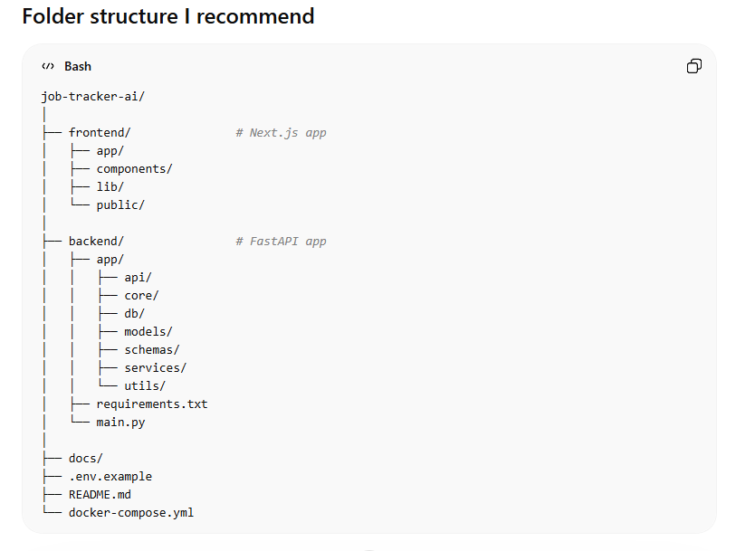
What we should do first
Ami recommend korbo first coding step hobe na OpenAI integration.
First step hobe project foundation.
Step 1
Set up:
- GitHub repo
- frontend app
- backend app
- Supabase project
- local environment
- base API connection
Step 2
Create database schema
Step 3
Create simple tracker UI
Step 4
Connect frontend to backend
Step 5
Then AI features
Eta professionally thik order.

Realistic MVP for publish
Prothom publishable version e ei features thaklei enough:
- signup/login
- add a job manually
- upload CV and JD
- ATS match analysis
- generate tailored cover letter
- set interview reminder
- SMS reminder
- dashboard with statuses

My recommendation on timeline
Tomar learning + building ek sathe cholbe, tai amra eta step by step korbo:
- architecture freeze
- local setup
- repo structure
- backend foundation
- frontend foundation
- DB
- auth
- tracker
- AI features
- notifications
- deploy
- polish and publish

Decision
Ami bolchi amra Colab bad diye professionally build korbo using:
Next.js + FastAPI + Supabase + OpenAI + Twilio + Vercel + Railway
Eita best balanced choice.
Next e ami tomake dite pari Step 1: exact setup from scratch, including:
- what to install on your laptop
- GitHub repo create
- frontend create
- backend create
- Supabase create
- first successful local run
Bolo: “start step 1” and ami ekdom scratch theke শুরু করবো.

